Useful tips on travelling in Norway, and what to do in Oslo
Visit Oslo: Official travel guide to Oslo
Currency, exchange and payments: The currency in Norway is Norwegian krone (NOK). 1 EUR = 9,92 NOK. The easiest and cheapest way for foreigners is to use a debit/credit card. There are very few locations where you won't be able to do that - small amounts are no problem, it won't raise eyebrows if you use a credit card to buy a cup of coffee. Taxis take credit cards, long distance buses too. For local buses, tram, Metro, and train in Oslo, buy tickets in any shop/kiosk with your credit card, or download the #RuterBilett Mobile ticket app.
If you must have some cash then cheapest would normally be to get it with debit/credit card from and ATM on arrival, or in the city.
Health & Safety standards are very high and visitors generally don't have to worry about personal security. For instance, tap water is not only drinkable but usually of very high quality (better than bottled).
Eating out: Norway's restaurants are expensive particularly for foreign visitors. Supermarkets offer good products for more reasonable prices. Budget supermarkets such as Kiwi, Rema and Prix can be found most places. Pizzerias are very common, although of varying quality these are often the least expensive place "to fill up" (often 120-150 NOK for a pizza). In comparison to a restaurant where a main course is anywhere between 160 - 290 NOK
Language: The language is Norwegian, but all Norwegians also understand and speak English.
Alcohol and smoking: Outside restaurants and pubs, beer can only be sold in shops before 8pm on weekdays and 6pm on Saturdays, while wine, spirits and strong beer must be bought at a Vinmonopolet outlet. Smoking is only allowed in a few designated places, and never allowed indoors.
Recommendations on what to do in Oslo from the Norwegian Health-NCP-team:
For city and seaside:
Take a walk along our beautiful Harbour Promenade, check out SALT- sauna and swim, before or after strolling along the seashore visiting our famous The Norwegian Opera and Ballet. Walk from the Opera towards Sørenga, , or head west again, pass SALT, , have a drink or lunch at VIPPA, pass beneath the Akershus fortess, pass the City hall and the Oslo Fish Market, to Aker Brygge and Tjuvholmen.with its city beach and Astrup Fearnley Museum of modern art.

From Rådhuskaia near Aker Brygge you can use your Ruterticket or day pass on one of the boats to the in the Oslo fjord. Take a ferry and go island hopping between the islands in the inner Oslo Fjord! With a regular public transportation ticket or an Oslo Pass you can easily get on and off any of the ferries going between Aker Brygge, Hovedøya, Lindøya, Nakholmen, Bleikøya, Gressholmen and Langøyene.
For the Forest lovers:
Go to Ekebergparken enjoy the modern sculptures embedded in the forest, and combine it with the "Munch view". How to get there: To make a day of it and have a meal at Ekebergrestauranten.

Have a whole day roundtrip from the city to the forest and back with ski-jump view/experience. Take the Metro line 1 to Holmenkollen station. Walk up to the skijump, and do the zipline if you dare. – Walk while enjoying the view up the road to Frognerseteren ( a 35 min walk)- have a coffee-on the terrace, enjoy the famous apple pie. Follow the signs towards "Sognsvann ST." to Sognsvann (1,5 hour walk in beautiful forest), from there take the Metro line 5 back to the city.
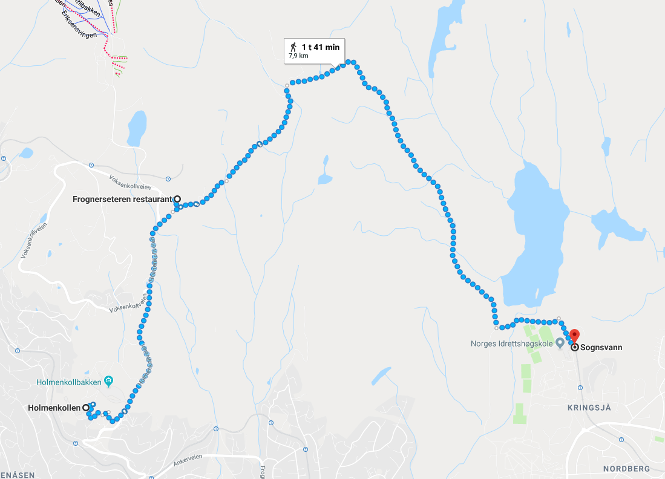

For the Viking and cultural history lovers:
Boats and outdoor museum at Bygdøy.Visit both the Vikingship museum, and the Norwegian Museum of Cultural History at beautiful Bygdøy peninsula. The ferry to the Bygdøy peninsula operates between March and October.
Departure every 20/30 minutes from City Hall Pier 3. Ruter's regular public transportation tickets (Ruter ticket) are not valid on the ferries to Bygdøy. Bus number 30 from the front of the City hall will take you to Bygdøy and the museums with a regular "Ruter" ticket.
